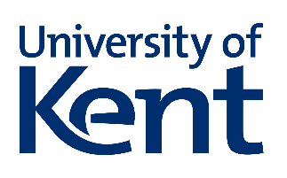
Social Psychology Alumni mini interview
Thank you for your interest in providing a mini interview.
Please complete each section and return the completed form along with a large digital photograph of yourself to Kristof Dhont, K.Dhont@kent.ac.uk

About you
Full name
Degree or programme
Year of graduation or leaving
Email address
Telephone number
Current role and organisation
Contact details provided will not be published. Please refer to the privacy statement overleaf for information on how we process your data.

Where are you at the moment?
Tell us about your current role. What does it involve? What are your responsibilities?

Tell us about your time at the University
You might want to share a bit about your background and what you were like when you started at the University of Kent. Why did you choose to study here, and what did you enjoy most?

Alumni wisdom
If you could offer a piece of advice, a tip or simply some words of encouragement to fellow members of the University of Kent community, what would it be?

Thank you very much for taking the time to complete this interview.
Please read and sign the consent statement below.
Consent statement
The information and photograph you provide may be used for promotional or recruitment materials for the University of Kent online, digitally and in print. This may include publication on the University website and social media channels, in electronic newsletters or printed publications. You can withdraw your consent at any time.
Signature*
* If you are sending this form by email and therefore cannot provide your signature, the receipt of your email confirms that give your consent for the above.
Date

