Client’s name: ________________
Date of birth: ________________
Tester: ________________
Is this a pre-group, post-group or six- month follow up measure? _____________

THE SEXUAL ATTITUDES AND KNOWLEDGE ASSESSMENT (S.A.K)

This tool can be used to evaluate the individual’s attitudes, knowledge and skills in the four main areas of:

- Understanding relationships
- Social interaction
- Sexual awareness
- Assertiveness

The participant is asked to respond to a series of questions, each accompanied by a picture (line drawing)

Procedure

Administering the tool
Using the questions from the SAKS and the corresponding pictures for each, read each question to the participant. Try to read the questions as closely as written. Use your own discretion in clarifying or simplifying the content as needed for the individual while preserving the essence of the question. When reading the questions, avoid giving cues like face gestures, or voice changes to direct the participant’s answer. Mark participants answer in the proper blank space.

Scoring

- After the assessment is completed mark the number of points correct for each question (except for attitude questions which are marked with *) in the blank to the left of each question on the SAKS question/ Answer Form.

- Use the “Final Score Form” to figure the number of answers correct in each area. For each question, locate the number listed under the area. For example, find question number 1 which is located under “Understanding Relationships”, on the Final Score Form. Then transfer the score (number of correct points) from the Question/Answer Sheet to the score form.

- For attitude questions, summarise the person’s answers in space under each category on the “Final Score Form”.

SEXUAL ATTITUDES AND KNOWLEDGE SCALE (SAKS)
QUESTION / ANSWER FORM
(For individuals with the ability to answer open ended questions)

Questions marked with a * are to assess the person’s attitudes and are not scored. Other questions are to be scored using the blanks to the left.

No of  possible  points | No of  points  correct
 | * | 1. | Mary and John are coming home from a date. They like each other very much. Is it okay for them to hug?
1 point | ________ | 2. | Joe is home alone. Someone knocks at the door. What should he do? (1 point)
3 points | ________ | 3. | Mary is sitting on the couch with Jane, her cousin. Is it okay for Jane to touch Mary’s breast? (1 point) If it is not okay who could she tell? (1 point) What should she do if the first person she tells does not listen? (1 point?)
1 point | * ______ | 4. | Jack is alone in his bedroom with the door closed. He is touching his penis. It feels good. Is this okay? Do you know another word fro this? (1 point)
1 point | * ______ | 5. | Jean is alone ion her bedroom with the door closed. She is touching her vagina. It feels good. Is this okay? Do you know another word for this? (1 point)
1 point | ________ | 6. | John is at work. He is rubbing his pants to make his penis feel good. Is this okay? (1 point)
1 point | ________ | 7. | John is hitchhiking (getting a ride from a stranger). Is this okay? (1 point)
 | * | 8. | Larry and Sam are homosexuals and love each other. Is it okay for them to touch each other’s penis in private?
 | * | 9. | Jenny and Marie are lesbians and love each other. Is it okay for them to touch each other’s vagina in private?
1 point | ________ | 10. | Kate does not want Mike to pull her shirt. What can she do? (1 point)
1 point | ________ | 11. | Mary lost her billfold (purse). Her bus money was in it. What should she do? (1 point)
1 point | ________ | 12. | John sees a new woman at his job. He wants to be friends with her. What could he do? (1 point)
1 point | ________ | 13. | Mary is home alone and the phone rings. She answers the phone. The person on the phone starts saying nasty things to her. What could she do? (1 point)
1 point | ________ | 14. | Liz is at work. Her boss, Mr. Smith wants to kiss her. What could Liz do? (1 point)
1 point | ________ | 15. | These two people are boyfriend and girlfriend. They want to have sexual intercourse, but they don’t want to have a baby. What should they do? (1 point)
1 point | ________ | 16. | This woman just found out she is pregnant and has told her husband. Tell me how she got pregnant. (1 point)
1 point | ________ | 17. | Scott is the only passenger on the bus. The bus driver stops the bus. He sits by Scott and tells him he is cute. Then he asks Scott to touch his penis. What should Scott do? (1 point)
1 point | ________ | 18. | What is this couple doing? (1 point)

- Using the drawing of the nude male and female, ask the client to identify the following body parts.

No. of possible points:12 |  | 19a. First point to the body part and ask what the name is (12 points)
No. of possible points:12 |  | 19b. Second, name the body part and ask the person to point to it on the picture (12 points)
 |  | 19 a. | 19 a. | 19 b. | 19 b.
 | Male | Correct | Incorrect | Correct | Incorrect
 | Toes | ________ | ________ | ________ | ________
 | Neck | ________ | ________ | ________ | ________
 | Lips | ________ | ________ | ________ | ________
 | Thigh | ________ | ________ | ________ | ________
 | Penis | ________ | ________ | ________ | ________
 | Testicles | ________ | ________ | ________ | ________
 | Female | Correct | Incorrect | Correct | Incorrect
 | Chin | ________ | ________ | ________ | ________
 | Hips | ________ | ________ | ________ | ________
 | Eyebrow | ________ | ________ | ________ | ________
 | Pubic Hair | ________ | ________ | ________ | ________
 | Vagina | ________ | ________ | ________ | ________
 | Breast | ________ | ________ | ________ | ________

Total of correct points for 19 a: ______
Total of correct points for 19 b: ______

Correct answers for individuals with the ability to answer open-ended questions

- Attitude question*
- Ask who it is before opening (1 point)
- No (1 point). She could tell trustworthy significant other, like parent, teacher (1 point). Tell someone else she can trust (1 point)
- Attitude question*. Masturbation (1 point)
- Attitude question*. Masturbation (1 point)
- No (1 point)
- No (1 point)
- Attitude question*
- Attitude question*
- Tell him “No” (1 point)
- Talk to someone you trust like bus driver, store clerk or make a phone call (1 point)
- Introduce himself or ask her name (1 point)
- Hang up (1 point)
- Tell him “No”, walk away (1 point)
- Use birth control, or name a specific type like condom, birth control pill (1 point)
- They had intercourse (1 point)
- Say “No” or leave the bus (1point)
- Having intercourse or having sex (1 point)

Final Score Form

Directions: For each question locate the number listed below and transfer the score (number of correct points) from the “Question/Answer Sheet”. For attitude questions summarise the person’s answers in the blank under each category (except assertiveness where there are none).

Understanding Relationships |  |  | Social Interaction
No. of possible points | Question | No. of points correct | No. of possible points | Question | No. of points correct
3 points | 3 |  | 1 point | 6
1 point | 12 |  | 1 point | 10
1 point | 14 |  | 1 point | 12
1 point | 17
6 total points |  | Total: | 3 total points |  | Total:

Summary of ‘attitudes’ (from questions 1, 8, and 9):
____________________________________________________________________________________________________________________________________________________________________________________________________________________________________________________________________________________________________________

Sexual Awareness |  |  | Assertiveness
No. of possible points | Question | No. of points correct | No. of possible points | Question | No. of points correct
 |  |  | 1 point | 2
3 points | 3 |  | 3 points | 3
1 point | 4 |  | 1 point | 7
1 point | 5 |  | 1 point | 10
1 point | 15 |  | 1 point | 11
1 point | 16 |  | 1 point | 13
1 point | 18 |  | 1 point | 14
24 points | 19 |  | 1 point | 17
32 total points |  | Total: | 10 total points |  | Total:

Summary of ‘attitudes’ (from questions 1, 4, 5, 8, and 9):
____________________________________________________________________________________________________________________________________________________________________________________________________________________________________________________________________________________________________________

Question 1

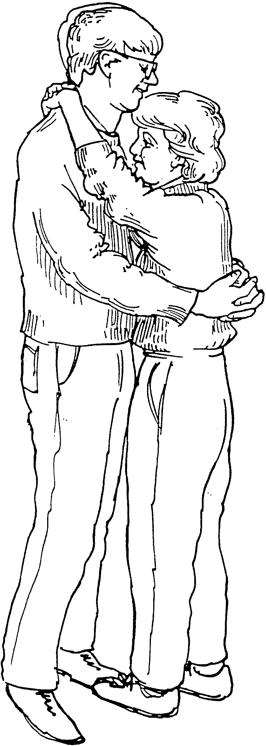

Question 2

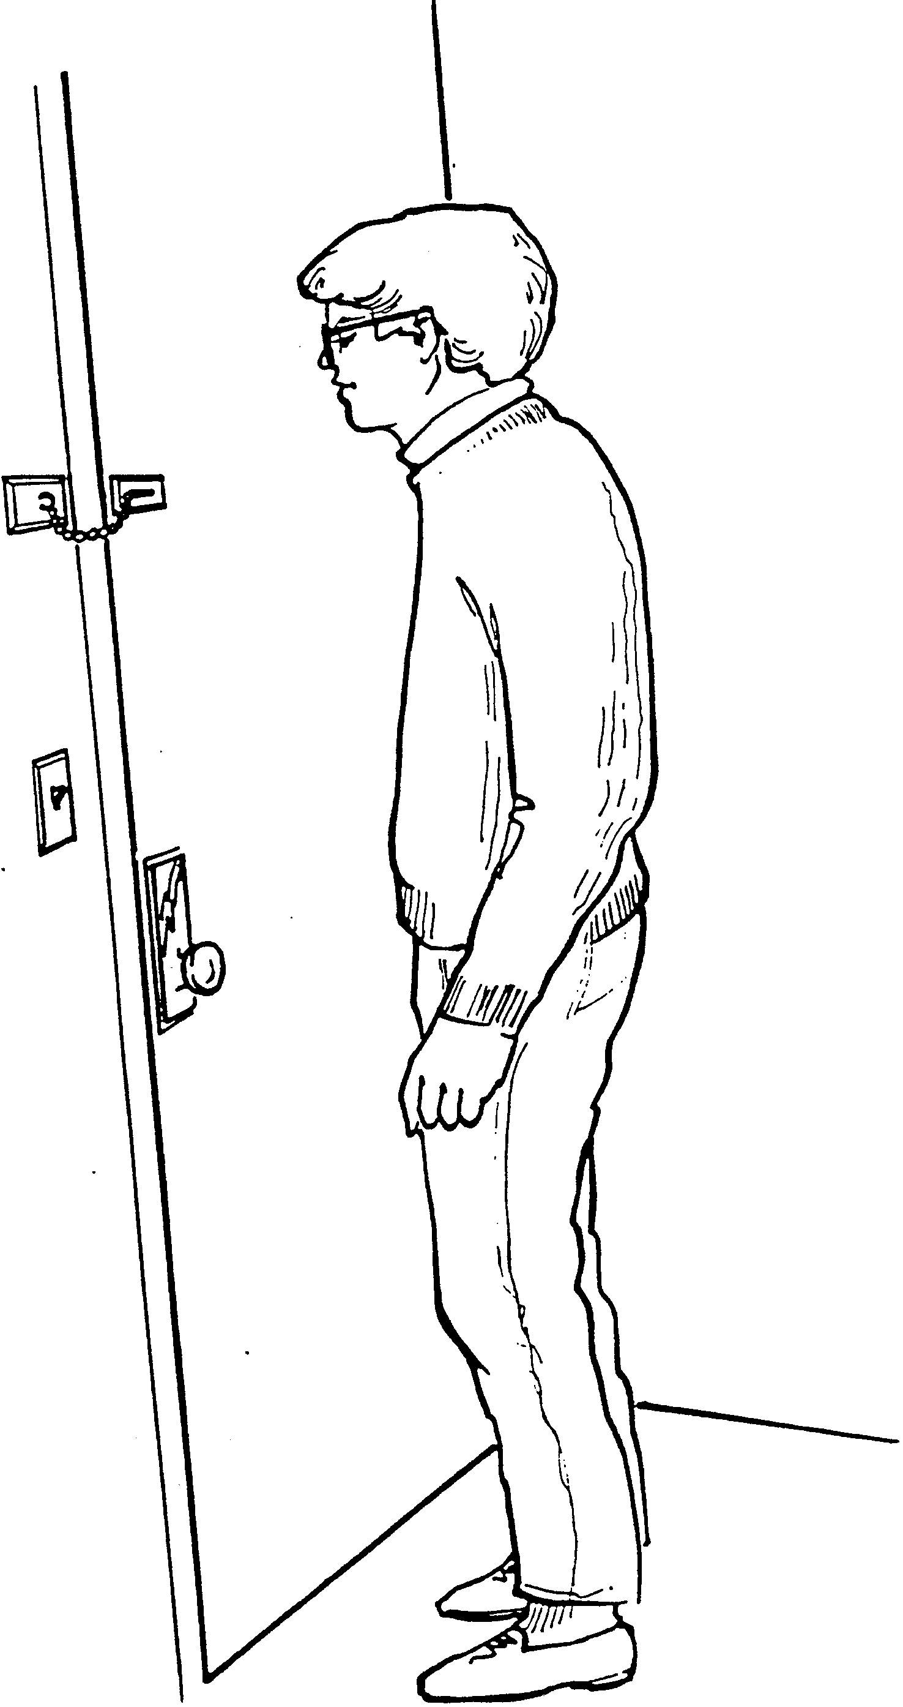
Question 3

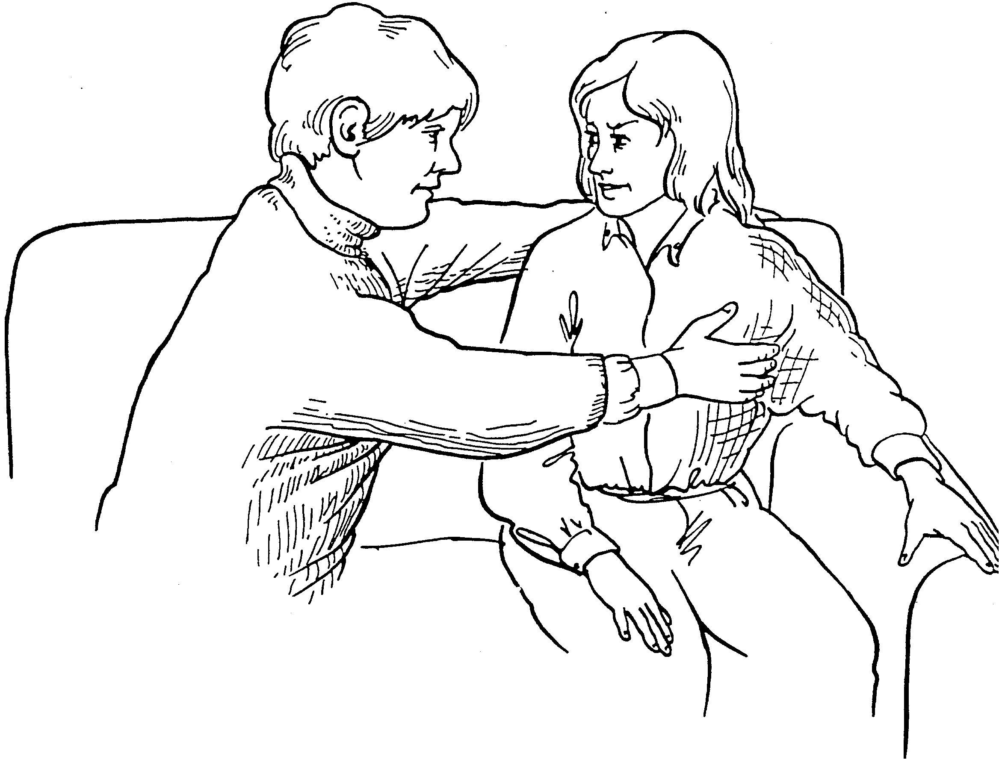

Question 4

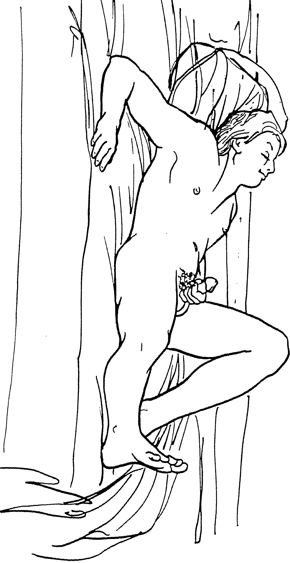
Question 5

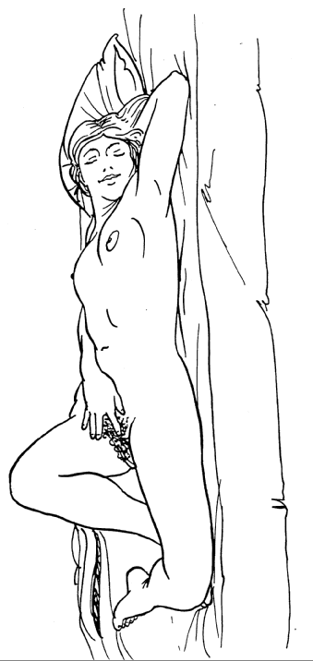

Question 6

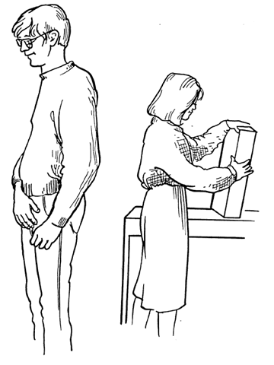

Question 7

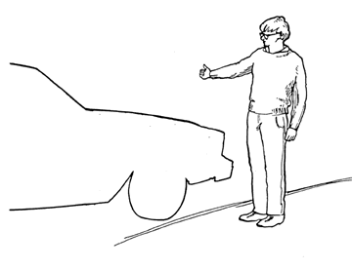

Question 8

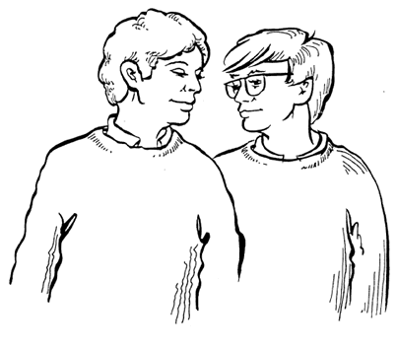

Question 9

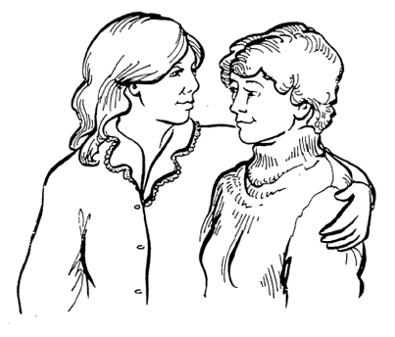

Question 10

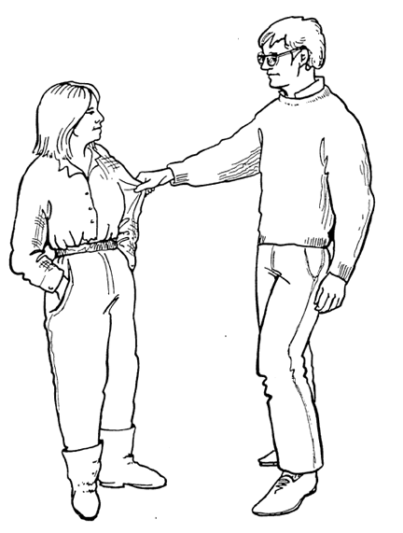

Question 11

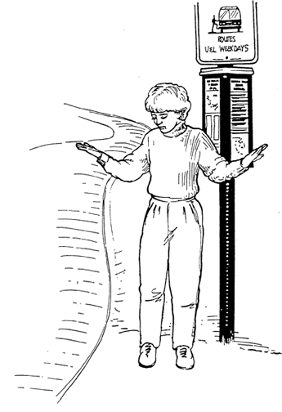

Question 12

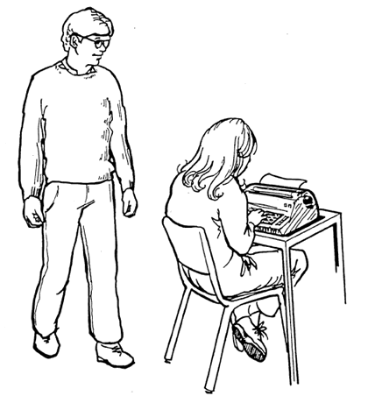

Question 13

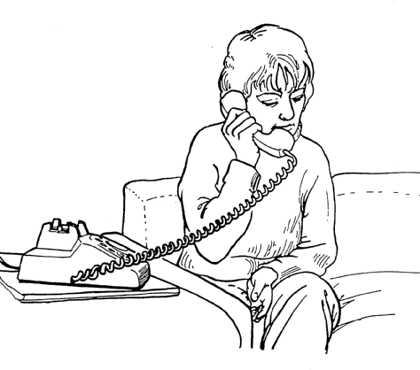

Question 14

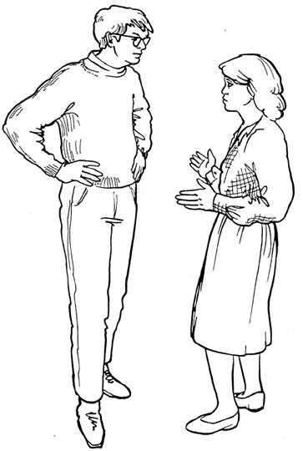

Question 15

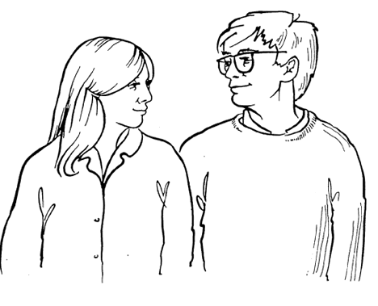

Question 16

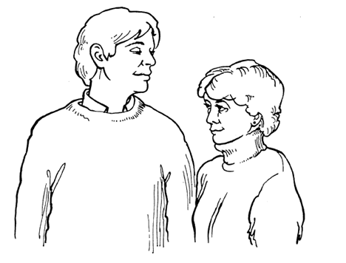

Question 17

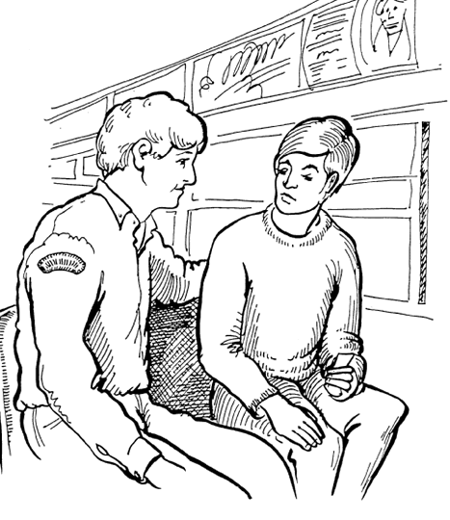

Question 18

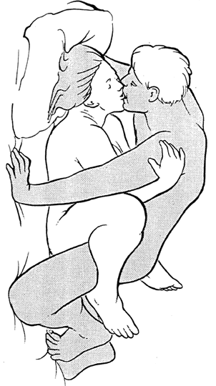

Question 19

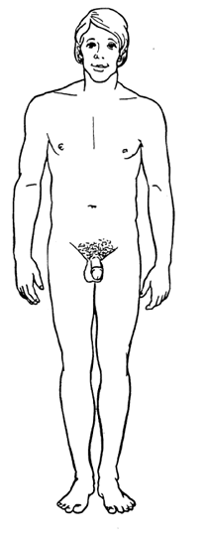

Question 19



