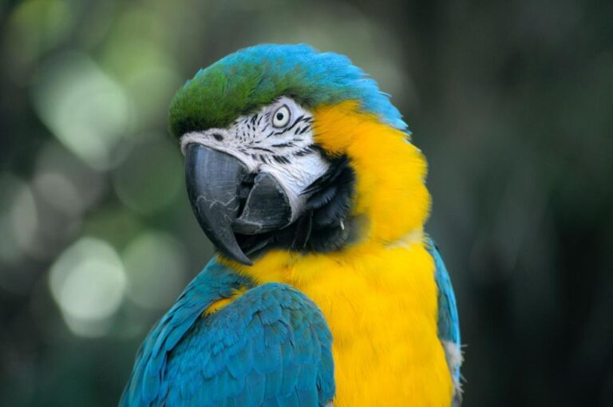

Animal Languages

Abstracts & bios
Speakers
Leonie Cornips (NL-Lab, Humanities Cluster KNAW & Maastricht University), Intraspecies and interspecies acknowledgements by the dairy cow
In this talk I will discuss a theory of a relational framework focusing on language as local meaning-making that, as Pennycook (2018) argues, is distributed among and between species, bodies, materiality, place and time. I will focus on intraspecies and interspecies acknowledging by various (dairy) cows in various intensive (dairy) farming contexts. Basing my observations on ethnographic research since mid 2018, I analyse the dairy cow as a linguistic actor who opens the interaction with the human and/or (dairy) cow who is passing by, by producing a routinized ‘mmmm’ – not as ‘noise’ – but as acknowledging the other (Cornips 2022). This ‘mmmm’-sound is produced with lips closed, sounds in the direction of /u/, that is, in human terms the sound is a so-called (semi-)closed central or back vowel, has a low pitch (F0) and remains more or less flat, at about 80 Hz. Not all individual dairy cows acknowledge the other vocally which might be related to the different personalities dairy cows have (Marino & Allen 2017).
The paper will demonstrate that dairy cows, within the power dynamics of industrial farming, make social meaning in their barns and outside in the pasture by relating to wellknown human(s) or passing dairy cows via a processually emergent quality arising from multiple assemblages of human and nonhumans, including material things, artefacts and spaces (Cornips & van den Hengel 2021; Cornips 2024 (in press)). This finding is important since acknowledging rituals of (dairy) cows may lead to a new interspecies ethics, i.e. in “respectfully engaging in new rituals with them can function as a gateway to further political interaction and extended conversations” (Meijer 2019).
Leonie Cornips is affiliated at the research group NL-Lab, Humanities Cluster of the Royal Netherlands Academy of Arts and Sciences, and professor Languageculture in Limburg at Maastricht University. Since 1994 she examined sociosyntax, methods in dialectology, and bidialectal child acquisition. More recently her research focused on local identity constructions through language practices including linguistic place-making and belonging. At present she examines intraspecies and interspecies interactions of dairy cows in various settings. She is conducting ethnographic fieldwork among different barns in the Netherlands.
Ana M. Ochoa (Tulane University), Vocalization as the philosophical site of struggle between the animal and the human
My work has centered on histories of vocalization and the philosophically problematic boundary between the human and the animal in colonial settings in the Caribbean and Latin America, where the question of how people sounded was often used to determine juridical outcomes of their status as citizens. More recently I have begun to work on the place of vocalizations in environmental justice struggles, in situations of military or corporate colonialism and imperial invasions. In this paper I philosophically look at vocalizations as a historically intense site for defining the status of the animal or the human in juridical struggles for human and environmental rights. I explore what counts as a voice for whom, how a voice needs to sound in order for the person to have the juridical status of a human, and how animal soundings are differentially heard in the midst of environmental and military struggles.
Ana M. Ochoa Gautier is a professor in the Newcomb Department of Music, the Department of Communication and the Department of Spanish and Portuguese at Tulane University in New Orelans. Her work is on histories of listening and the decolonial, on sound studies and climate change, and on the relationship between the creative industries, the literary and the sonic in Latin America and the Caribbean. Her current projects explore the bioacoustics of life and death in colonial histories of the Americas and the relationship between sound, climate change and the colonial. She has been a Guggenheim Fellow (2007-2008) and has served on the advisory boards of the Society for Cultural Anthropology, and the Smithsonian Center for Folklife and Cultural Heritage. Her book, Aurality, Listening and Knowledge in Nineteenth-Century Colombia (Duke University Press, 2014) was awarded the Alan Merriam Prize by the Society for Ethnomusicology. She is also the author of Músicas locales en tiempos de globalización (Buenos Aires: Norma 2003) and Entre los Deseos y los Derechos: Un Ensayo Crítico sobre Políticas Culturales (Bogotá: Ministerio de cultura, 2003) and numerous articles in Spanish and English. Her forthcoming book, La Vida de los Sonidos (The Life of Sounds), will be published by Mimesis Ediciones in Chile.

Andrea Gutiérrez (University of Texas at Austin), An Appraisal of Animal Language in Early India from Parrot to Elephant
Early South Asian texts and their understanding of animal language stand out from other premodern understandings of animal speech. Historical South Asian writers—and not only storytellers—were very preoccupied with the extent and capacities of animal speech, especially in relation to human speech capabilities. Focusing on the Indian parakeet and the Asian elephant, Gutiérrez will work through animal speech as understood in a number of texts ranging from poetry to philosophical tracts. Early precedents in epistemology accepted certain animals’ speech—especially parrots’—as a valid means of attaining knowledge, whether as testimony or teaching. Meanwhile, legends from Indian epics like the Mahābhārata presented etiologies of how animal speech organs came to be the way they are, illustrated in this paper with the example of the elephant’s tongue. This paper will also approach alternative modes of animal language and interspecies communication as they appear in classical and medieval texts both literary and technico-scientific, using Sanskrit and Tamil sources.
Andrea Gutiérrez began her work on animal studies in earnest during her second MA, with a thesis on “The Parrot’s Voice & the Partridge’s Feathers: The Languaging of Animals & Animal Language in Early Indian Texts” (2014). Work has continued through the present day, and she is deep into researching the history of the captive elephant in South Asia, from medieval through modern times.
Publications on animals include a contribution on “Elephant Education, Linguistic Articulation, Punishment? Gajaśikṣā as Interspecies Communication in Elephant Care Manuals of Early India” (Bloomsbury, 2023) and “Embodiment of Dharma in Animals” in Hindu Law (History of Hinduism Series, OUP 2018). Gutiérrez is presently preparing a digital edition of an early 20th-century elephant care manual from South India as part of a Scalar site for the digital humanities called An-Elephant-Archive.

