Rethinking Fables in the Age of Global Environmental Crisis
Workshop 2 (online)
January 29-30, 2024
Fabulous Species/Human-Animal Relationships
January 29
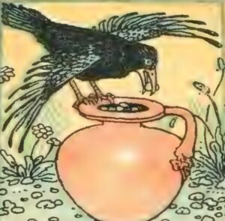
9-11am UK time Wisdom of Crows: Fables, Science, Storytelling
Chair: Matthew Churlew
What can a crow fable teach us about the intelligence, cognitive abilities, and emotional lives of corvids? What roles can scientists, ethologists, and multispecies ethnographers play in creating new crow fables befitting our evolving relationship with these amazing birds? This session brings together three leading crow experts to share their research in relation to fables, and to discuss how we might learn to listen to crows as co-fabulists, and the important lessons they have to impart.
Jo Wimpenny, The Crow and the Pitcher: how Aesop's fable flew from fiction to fact
Aesop's fable, ‘The Crow and the Pitcher’, paints the crow as an insightful problem-solver, a characterisation that is common in stories of crows from many different cultures. But only in recent decades has scientific research been conducted into the minds of corvids including, in 2009, a study specifically about the behaviour portrayed in Aesop's fable. In this talk, I will explore how Aesop's fable became integrated into scientific research, the kinds of studies it inspired, and how those studies have contributed to the thriving field of corvid cognition.
Kaeli Swift, Crows: From undertaker to garbage man and the real-time fable of the Anthropocene
Thom van Dooren, Exploring the border between ethics and ethology with crows
Jo Wimpenny is a zoologist and science writer based in Oxford, UK, with a research background in crow cognition and the history of science. Her DPhil investigated cognition in tool-using New Caledonian crows, and she then conducted postdoctoral research on the history of ornithology, co-authoring the award-winning Ten Thousand Birds: Ornithology Since Darwin (Princeton U. Press, 2014) with Tim Birkhead and Bob Montgomerie. Her book, Aesop’s Animals: The Facts Behind the Fables (Bloomsbury Sigma, 2021), critically appraised the characterisation of some of Aesop’s best-known animal characters, asking how they match up against the latest scientific research. For her current project (to be published by Bloomsbury Wildlife), she is delving deeper into the origins and nature of human-animal relationships, focusing on beasts in our cultures that are typically villainised or misunderstood.
Kaeli Swift earned her PhD in avian behavioral ecology from the University of Washington. While there, she studied American crows, with a special emphasis on behaviors around death. She is currently a postdoctoral researcher at the University of Washington, where she is studying the breeding ecology of the Tinian monarch. You can read her popular science articles on her blog, corvidresearch.blog. You can also find her on Twitter, Instagram, and TikTok at the @corvidresearch handle. Video, audio, and print reports of her research have been featured by: National Geographic, PBS, the New York Times, The Atlantic, Ologies podcast, Science Friday and many others
Thom van Dooren, FAHA, is Professor of Environmental Humanities and Deputy Director of the Sydney Environment Institute at the University of Sydney. His research and writing focus on some of the many philosophical, ethical, cultural, and political issues that arise in the context of species extinctions and human entanglements with threatened species and places. He is the author of Flight Ways: Life and Loss at the Edge of Extinction (Columbia UP 2014), The Wake of Crows: Living and Dying in Shared Worlds (Columbia UP 2019), and A World in a Shell: Snail Stories for a Time of Extinctions (MIT 2022). www.thomvandooren.org
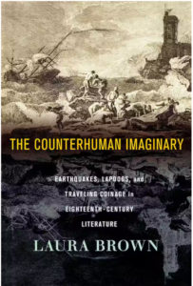
4-5:30pm UK time: Counterhuman
Chair: Lucinda Cole
Speaker: Laura Brown
In this session, Professor Laura Brown (Cornell) will discuss and lead a workshop on some of the theoretical ideas she explored in her new book, The Counterhuman Imaginary: Earthquakes, Lapdogs, and Traveling Coinage in Eighteenth-Century Literature (Cornell UP, 2023), to explore their relevance to the animal fable.

Laura Brown (Ph.D., Univ. of California, Berkeley) is the John Wendell Anderson Professor in the Department of Literatures in English at Cornell University. She has published widely in eighteenth-century studies, and has served as President of the American Society for Eighteenth-Century Studies and as Vice Provost for Undergraduate Education at Cornell University. She studies gender, slavery, and imperialism, the portrayal of animals, and the counterhuman force of “things,” storms, and earthquakes in eighteenth-century literature. Her most recent book, The Counterhuman Imaginary, extends her ongoing work in posthuman theory and critique.
Lucinda Cole is Conrad Humanities Scholar and Associate Professor of English at the University of Illinois, Urbana-Champaign, where she is also Affiliate Professor with the Institute of Sustainability, Energy, and the Environment. Her publications include many articles on animals, animality, and ecology, along with the award-winning monograph Imperfect Creatures: Vermin, Literature, and the Sciences of Life, 1600-1740 (University of Michigan Press, 2016). She is now finishing a book on cattle murrains, contagion, and the medical posthumanities.

5:30-6:45 UK time Framing Fables (Group Fable Writing session)

January 30
9-11am (UK time) Storying Animals in Public Places
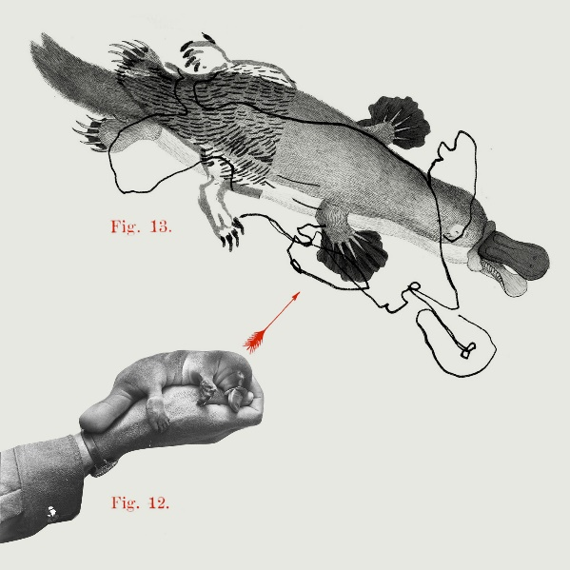
In this session we will present an overview of two current projects focused on telling unexpected animal stories to broad public audiences. These projects are “Animal Allegories” (http://animalallegories.com.au/) and “Animal Tales” (a trail of animal stories through the Chau Chak Wing Museum in Sydney). The projects work in a variety of media, including written texts, audio and video, illustration, augmented reality, and the creation of an immersive audio trail. In different ways, they seek to draw audiences into encounters with animals that will challenge, provoke, and redo their sense of the world and our relationships with other species. The projects are both grounded in the understanding that as we adapt to frightening new ecological realities, and as we fight to keep the future liveable for all creatures, the power of imagination plays a critical, if underappreciated, role. We know stories can't save the world. But they can provide moments of respite, transporting us into an imaginative realm where new possibilities shimmer briefly into view.
Presenters:
Zoë Sadokierksi is a designer, creative producer and Associate Professor at the University of Technology Sydney School of Design.

Ceridwen Dovey is a writer of fiction and creative nonfiction, and a filmmaker.

Thom van Dooren is Professor of Environmental Humanities in the School of Humanities and Deputy Director of the Sydney Environment Institute, University of Sydney.

Julia Kindt is Professor of Classics and Ancient History at the University of Sydney.

Andrew Burrell is Senior Lecturer in the School of Design at the University of Technology Sydney.

13:30-15:00 (UK time) Therolinguistics / Fabulous fiction (Chair: Susan McHugh)

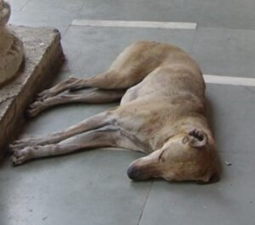
Matthew Churlew, ‘What Grew from the Acacia Seeds: A Century of Therolinguistics’
A review of the edited volume A Century of Therolinguistics, published by Pluriversity of Tartu Press in 2074.

Jeanne Dubino, Stray Dogs in Contemporary Fabulous Fiction
Contemporary fabulous short fiction, with its tight, tripartite structure of introductory sketch, action, and concluding comment (Korhonen 4), can serve as the latest incarnation of the genre of the fable, or what Sheila Roberts calls the “grim contemporary animal fable” (74). It is grounded in realism, offers an “indeterminate” moral (Danta 17), and invites readers to consider the animals’ perspectives. Stray dogs play an especially relevant role in this genre. By definition, strays of any kind do not inhabit any one place or position. Along the canine scale, they fall somewhere between the domestic and the wild. More than any other kind of dog, the stray is a “stateless refugee, tolerated and occasionally pitied as a hanger-on, but never properly assimilated or accepted” (Serpell 254). Multiple critics have noted that the moral of classical fables tends to “might makes right.” In contemporary animal fables by global writers such as the Indian R. K. Narayan, Pakistani Saadat Hasan Manto, Iranian Sadegh Hedayat, and Turkish Orhan Pamuk, the presence of stray dogs tends to evoke readerly sympathy—but not only that. In a world where, now, more than 280 million people live in countries outside of their birth (World Migration Report), these stories suggest how both stray dogs and displaced people represent threats to social orders premised on the notion of status and stasis.
Matthew Chrulew is Senior Research Fellow at Curtin University, Perth, Australia. He is co-editor of Kin: Thinking with Deborah Bird Rose (Duke UP, 2022), Extinction Studies: Stories of Time, Death and Generations (Columbia UP, 2017), Foucault and Animals (Brill, 2016) and Animals in the Anthropocene: Critical Perspectives on Non-Human Futures (Sydney UP, 2015). He is series editor of Animalities (Edinburgh UP). He has also co-edited numerous special issues of journals including Angelaki, SubStance and parallax.
Jeanne Dubino is a professor of English, Global Studies, and Animal Studies at Appalachian State University, North Carolina, USA. She has been a visiting assistant professor of literature and Women’s Studies at Bilkent University, Turkey; a Fulbright Scholar/Researcher at Egerton University, Kenya; Fulbright Specialist at Northeastern University, China; and visiting scholar at Ain Shams University, Egypt. This summer she will be a Fulbright Specialist at the Federal University of Paraíba, Brazil. Her publications include collections, essays, articles, and reviews on Animal Studies, travel, gender, and Virginia Woolf. She is currently working on a monograph on stray/street/free-ranging dogs in literature.

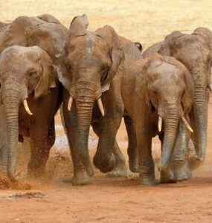
3:30-5:30pm (UK time) Elephant Fables (Chair Nigel Rothfels)
Tobias Menely, War and Peace with Elephants: From World Literature to Planetary Storytelling
This talk asks how we might read multispecies narratives without assuming that resolution – the achievement of order or justice, the realization of a moral or meaning – amounts to a consolidation of the human. I’ll discuss a global corpus of stories concerned with conflict between humans and elephants, including Anglophone novels of the ivory trade, Buddhist Jataka fables, North American and African oral histories, and new narratives of conservation in the Anthropocene. These narratives, I’ll argue, negotiate a geopolitical domain that exceeds the human. By this, I mean, first, that what is at stake, unmade and remade through violence, are the identities of those recognized within political categories such as sovereignty and freedom, and, second, that the relations of peoples and states are inexorably shaped by ecological factors, including the environment-making agency of proboscideans. I’ll ask, in short, what these stories illuminate about human-elephant relations as a matter of war and peace.
In navigating the linguistic and disciplinary translations involved in this comparatist reading, I’ll propose a category of planetary storytelling more capacious than world literature, concerned with how multispecies narratives circulate across history, cultures, and media forms.
Kim Stallwood, Topsy: Myth or Reality
If anyone knows anything about Topsy it’s because they’re one of the 1.5 million views on YouTube of her electrocution on Coney Island, New York in 1903. More is known about what happened on the day she died than for most of the rest of her life. This lack of information is exacerbated by myths, including whether she was a casualty of the War of Currents between Edison and Westinghouse, and whether Edison was present or involved with her murder electrocution. Further, there are stories of elephants refusing to walk over the ground where she was buried at Coney Island and reports of her appearing as a ghost many years later. Finally, there are discrepancies in the contemporary newspaper coverage. My talk will separate myth from reality.
Sospeter Kiambi, Encounter with Tim, the ‘Super Tusker’
In this presentation, Sospeter Kiambi, a Senior Research Scientist at the Wildlife Research and Training Institute and a doctoral candidate at the Durrell Institute of Conservation and Ecology (DICE, University of Kent), will share his research on elephants and his elephant fable.
Tobias Menely is Professor of English at the University of California, Davis. He is the author of The Animal Claim: Sensibility and the Creaturely Voice (Chicago 2015) and Climate and the Making of Worlds: Toward a Geohistorical Poetics (Chicago 2021). With Jesse Oak Taylor, he co-edited Anthropocene Reading: Literary History in Geologic Times (Penn State, 2017). He is currently writing a book about megafauna conservation in the Anthropocene.
Kim Stallwood is an author and independent scholar with more than 45 years of personal commitment as a vegan and professional experience in leadership positions with some of the world’s leading animal rights organizations. He is a leader in preserving the history of the animal rights movement. The British Library in London acquired the Kim Stallwood Archive in 2020. Tier im Recht, the Zurich-based animal law organization, established the Kim Stallwood Collection in 2022. He is a member of the Culture & Animals Foundation board of directors and served as the volunteer executive director of Minding Animals International from 2012 to 2017. His book, Growl, was published by Lantern in 2014. He is a contributor to various academic anthologies. Currently, he is writing the biography of Topsy, the female Asian elephant electrocuted to death on Coney Island, New York, in 1903. He holds dual UK and US citizenship and lives in England.
Sospeter Kiambi is a Senior Research Scientist at Wildlife Research and Training Institute. He has over 17 years of working experience in wildlife research. He is presently stationed at the department of populations and habitat dynamics based at the Institute’s headquarters in Naivasha. Sospeter obtained a degree in Wildlife Conservation and Management from the University of Nairobi and MSc in Conservation and International Wildlife Trade from the University of Kent in the United Kingdom, and is currently enrolled for a PhD at the Durrell Institute of Conservation and Ecology (DICE) in the same university. His research aims to investigate the ‘Human-elephant co-existence in a post-ivory ban landscape.’ https://research.kent.ac.uk/gcdc/person/sospeter-mwirigi-kiambi/ Amongst many other courses, Sospeter is a trained and registered Environmental Impact Assessment and Audit expert with the National Environmental Management Authority (NEMA) of Kenya and a trained trainer on Monitoring the Illegal Killing of Elephants (MIKE) and the black rhino monitoring using the IUCN African Rhino Specialist Group (AfRSG) monitoring guidelines. He is skillful in biodiversity management, ecology, geospatial and statistical analysis.
Nigel Rothfels is a historian of animals and culture. He is the author of Savages and Beasts: The Birth of the Modern Zoo, a study of the origins of naturalistic displays in zoos, which was published in 2002, and Elephant Trails: A History of Animals and Cultures, a history of Western ideas about elephants, published in 2021. He is the co-author of a book about the elephants and staff at the Oregon Zoo called Elephant House, published in 2015, and the editor of the multidisciplinary collection Representing Animals (2002). His current research focuses on butterfly collecting in the late nineteenth century.

