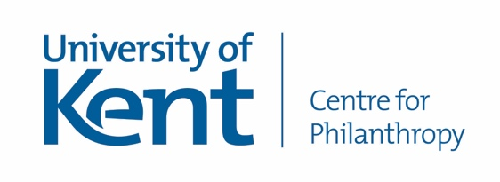

Helping charities to successfully,
ethically, and enjoyably raise more money

We are delighted to share details of a free 3 week online fundraising course run by the Centre for Philanthropy at the University of Kent, with support from Pears Foundation.
This free online course has already helped almost 10,000 people get the hang of the essential skills and knowledge needed to raise funds for good causes. Here’s what some previous participants have said:

“I went from knowing very little to feeling that I could make a significant contribution to a fundraising project and all in under three weeks of relatively light study. The reason for ‘progress’ in this subject, is entirely due to how the subject was taught. The teaching staff did an incredible job.”
“The course has consolidated my existing knowledge, taught me aspects I was previously unaware of and made me enthusiastic that I am on the right path. The educator interaction was excellent, and the resources were extremely useful. Thank you.”
“We are in the midst of reworking our individual giving strategy, including especially our approach to membership. Getting down to basics and a broad scope of fundraising has hugely helped in how I look at this project to approach it from the ground up.”

The course is available to follow at any time. In each of the 3 weeks all participants will watch short videos of fundraising and academic experts explaining key concepts, read short texts, and do brief exercises to cement the learning. By the end of the 3rd week you will have created a fundraising strategy for use in your organisation. You can expect to spend around 4 hours per week on the course.
This course is open to anyone, please join by registering with Futurelearn then selecting this course:
https://www.futurelearn.com/courses/fundraising-for-non-fundraisers
Please feel free to share this link with your contacts – all those seeking funds for good works are welcome.
For more information about the Centre for Philanthropy at the University of Kent, including details of our staff team and free access to many research reports, please see our website:
https://research.kent.ac.uk/philanthropy/

