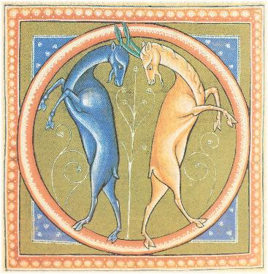
TEATR PIEŚŃ KOZŁA
Purkyniego 1
50-155 Wrocław, Poland
tel./fax. +48 71 342 71 10
e-mail:office@piesnkozla.pl
www.piesnkozla.pl

Workshop application form
Please return this form to us by post, fax or, e-mail.

Name: | Phone:
Age: | Fax
Nationality:
Address | e-mail
Address | If possible, we will contact you by email. Please indicate if this is not convenient:
Education

Workshop experience

Theatre experience

Are you currently a member of a theatre group?
If so, please briefly describe your group.

Are you interested in 1 week workshops/1 month projects/longer co-operations? *
Are you interested in Spring or Summer workshops?
How did you find out about Piesn Kozla workshops?

* Please select as appropriate
Once we have received this form from you, we will contact you with details of upcoming workshops.

