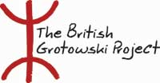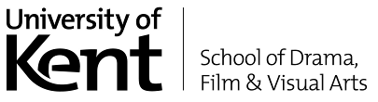

WORK ENCOUNTER
TRACES

The British Grotowski Project addresses practitioners, teachers and performers who want to investigate Polish director Jerzy Grotowski’s practical legacy and examine how to develop further current performance practice inspired by this starting point. This laboratory is a chance for groups and individuals with a specific interest in this area to progress their practice through intensive work led by three British performers/teachers, who have extensive experience in work connected to Grotowski:

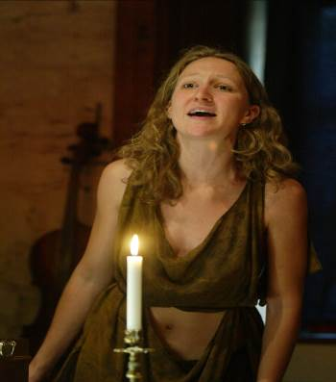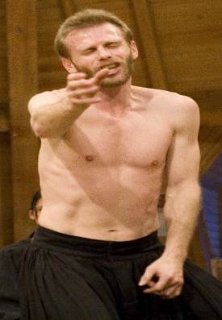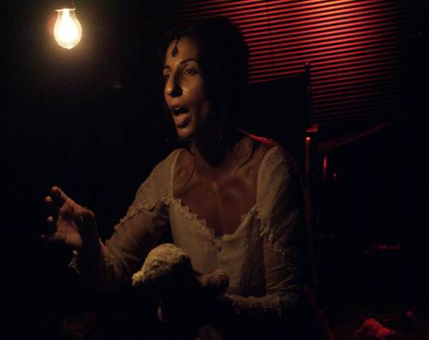

Anna-Helena McLean (independent performer/teacher, formerly of the Centre for Theatre Practices ‘Gardzienice’)

Ian Morgan (formerly of the Workcenter of Jerzy Grotowski and Thomas Richards, and currently with Song of the Goat)

Persis Jade Maravala (performer and artistic director of Para Active)

The 6 day laboratory will take place on the Canterbury campus at the University of Kent from Monday 14th – Saturday 19th April, 2008.

Places are limited to a maximum of 25 people. Participation fee: £150 per week per person. Participants must pay their own accommodation, travel and subsistence.

For enquiries or to apply, please send by 1st March a CV + 300 word letter of interest to:
Dr Giuliano Campo gc71@kent.ac.uk tel (0) 1227 824918 or
Professor Paul Allain paa@kent.ac.uk tel (0) 1227 823338
c/o Eliot College, University of Kent, CT2 7NS

